H1: Long Non-coding RNA Sequencing (lncRNA-seq)

Tab 1: Overview

H2: Introduction to lncRNA Sequencing

Long non-coding RNAs (lncRNAs) are a moderately abundant fraction of the eukaryotic transcriptome, which are comprised of longer than 200nt non-coding RNAs (ncRNAs) , including lincRNAs (intergenic lncRNAs), intronic, anti-sense, sense and bidirectional lncRNAs, which do not encode proteins. Effects of lncRNAs show evidence on multiple cellular functions and perform as prime targets on the regulation of gene transcription, post-transcriptional modifications, and epigenetics. lncRNA sequencing (lncRNA-seq) is a powerful NGS tool to study functional roles in diverse biological processes and human diseases, such as cancer and neurological disorders.

The progressive library preparation of Novogene’s lncRNA-seq service enables information enrichment and gene expression profiling for both coding and non-coding transcripts from a highly sensitive transcriptomic perspective. Through the application of bioinformatics analysis, the strand orientation and the regulatory association between lncRNA and targeted mRNA can be investigated, all in a single run.

H2: How does lncRNA sequencing work?

LncRNA-seq has been opening new and exciting research possibilities, including:
- Profiling known and novel transcripts and identifies variations
- Predicting targeting genes of lncRNA
- Identifying biomarkers for cancer/disease diagnostics and classification
- Discovering regulation between lncRNA and mRNA

H2: lncRNA-seq Specifications: RNA Sample Requirements

Library Type | Sample Type | Amount | RNA Integrity Number  (Agilent 2100) | Purity  (NanoDrop)
lncRNA Library | Total RNA | ≥ 500ng | Animal ≥ 6.5, Plant ≥ 6, with smooth baseline | OD260/280 = 1.8-2.2;  OD260/230 ≥ 1.8;
Exosomal lncRNA Library | Exosomal RNA | ≥ 20ng | Peak between 25-200nt, FU> 10, no peak > 2000nt

Note: Sample amounts displayed are for reference only. Download the Service Specifications or Sample Requirements to learn more. For detailed information, please contact us.

H2: lncRNA-seq Specifications: Sequencing & Analysis
Sequencing Platform | Illumina Novaseq 6000
Read Length | Paired-end 150
Recommended Data Output | ≥ 40 million read pairs per sample
Standard Data Analysis | - Data Quality Control  - Structural Analysis (Alternative Splicing & Variation Calling)  - lncRNA Identification & Annotation  - Expression Quantification & Differential Expression Profiling  - Functional Enrichment Analysis  - Protein-Protein Interaction (PPI) analysis  - lncRNA Target Gene Prediction
Note: Parameters are displayed for reference only. Download the Service Specifications to learn more. For detailed information, please contact us.

H2: Novogene lncRNA Sequencing Project Workflow

The workflow of the lncRNA-seq initiates from the preparations and the quality evaluation of samples. The ribosomal RNA (rRNA) is depleted for target transcript enrichment. The fragmented RNA undergoes reverse transcription into cDNA. Strand-specific libraries (also known as stranded libraries, directional libraries) are prepared, and the sequencing is performed using a paired-end 150bp strategy on the Illumina platform. The downstream processing follows the well-established and mature Novogene pipeline, which guarantees the highest quality of the results. Customized bioinformatics solutions are available upon request.

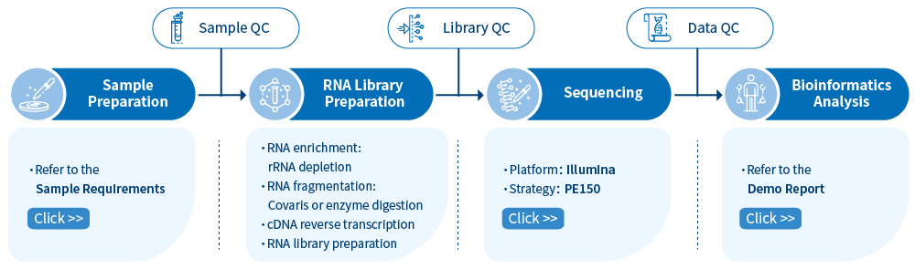

Publications

H2: Featured publications using Novogene lncRNA service

LncRNA-seq is a powerful tool that not only reveals the quantification and functional enrichment of the target transcripts but also indicates the strand orientation and regulatory relationship between lncRNA and targeted mRNA. There list some exciting publications that have used Novogene’s lncRNA-seq services.

